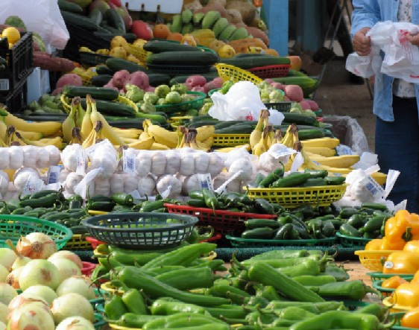

NEW Kings’ Shops Farmers Market, at Waikoloa Beach Resort
Wednesdays 8:30am – 1:00pm
Just in time for the holiday celebrations!
Big Island grown produce, orchids, cut flowers and farmed seafood
Locally produced honey, coffee, tea, artisan breads & baked goods
Support our local farms and producers. See you there.
